This form has been designed to assist in recording your Group opinions and any queries that arise during the Group discussion, or at the Topics for Conference Forum.
Please bring your copy of the Topics, Attachments, Service Manual, and Guidelines if you have them. Also a copy of this cheat sheet and a pen. There is no need for groups to vote on the topics at the forum. Some may wish to, but there is also the opportunity to go back to your groups with hopefully improved information, and then vote as a group
Every member is welcome to attend this forum. It is to give us all an informed conscience to vote from, in preparation for the Annual Group Conscience of all Australia - the Conference - which takes place in Sydney starting on November 7TH.
Group opinions on the topics help the Delegate convey to Conference the outcomes of the discussions from this Area.
Should members decide to use this aid please read the full Topic including:
- All the sections of the Topic, such as the background.
- Where there are attachments, noted in RED should be studied too.
Please understand that in no way is this forum intended to influence the way groups vote.
Venue and date: AS PER THE FLYER

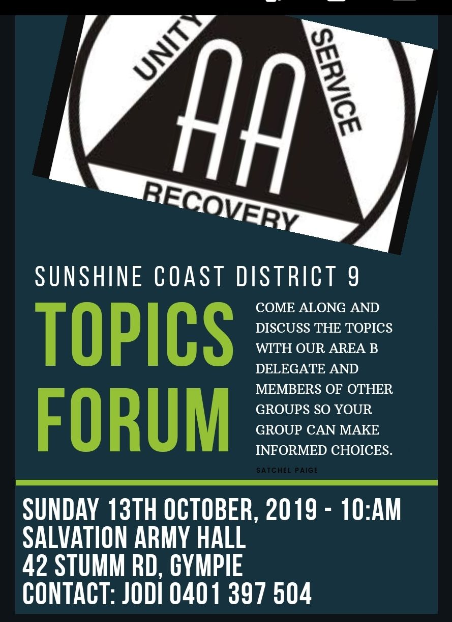

 | Topic Number & Description | For | Against | Abstain | Comments
 | CONFERENCE FLOOR
TOPIC #005/2019 ATTACHMENT Operation of Conference Delegates Committees.
To rescind Floor Action 2013/041 “Resolved by a show of hands, that all Conference Committees should change their CS & P documents so that all Conference members have equal participation rights in keeping with Concept IV.” Thereby returning the operation of the Conference Delegates Committees to their intended operating formula.

 | POLICIES AND ADMISSIONS
TOPIC #001/2019

That Conference undertake a review of its current voting structure, having regard to the Right of Participation, to identify options for change that would enable Area Delegates to constitute more than two-thirds of the voting members at the Australian General Service Conference.

TOPIC #012/2019
Encourage alcoholic-addicts to maintain anonymity as a drug addict at AA meetings.

TRUSTEES COMMITTEE
NO TOPICS ALLOCATED

Topic Number & Description | For | Against | Abstain | Comments
REPORT, CHARTER AND SERVICE MANUAL COMMITTEE
TOPIC #009/2019
Currently there is no specific provision for members to leave a nominated Central Service Office a sum of money in their will. This topic suggests that the AA Guideline relating to CSOs, GL-12, should make such a provision.

TOPIC #019/2019 ATTACHMENT

Amend the Australian Conference Charter on page 72 of the Australian Service Manual, (restoring it to our founder Bill W’s original wording) to read that “Area Delegates make up at least two thirds of the Conference body”.

TOPIC #022/2019

That conference resolve to correct the lack of 2/3 majority of delegate votes on the conference floor, as stated in the Conference Charter.
Due to a historic flaw and our inability to increase the number of Areas in Australia in our General Service structure, there is not a 2/3 majority of delegate votes on the conference floor. This proposal will restore the 2/3 majority required by Concept 1.

Topic Number & Description | For | Against | Abstain | Comments
PUBLIC INFORMATION & COOPERATION WITH THE PROFESSIONAL COMMUNITY (PI&CPC)
TOPIC #008/2019 ATTACHMENTS X4

AA could do with a few more colour A4 PI poster options. Please find my suggested options attached.

TREATMENT FACILITIES & SPECIAL NEEDS COMMITTEE
NO TOPICS ALLOCATED
CORRECTIONAL FACILITIES COMMITTEE
NO TOPICS ALLOCATED
FINANCE
TOPIC #020/2019
General Service Board establish a permanent AA Convention bank account

TOPIC #021/2019
A New Funding System for the AA Convention

Topic Number &Description | For | Against | Abstain | Comments
REMOTE COMMITTEE
TOPIC #016/2019 ATTACHMENT

To compile and publish a selection of personal stories of Aboriginal and Torres Strait Islander AA members, their journey to AA and experience, strength and hope.

The book could be an excellent resource to carry the message to prisons, health services and other Aboriginal and Torres Strait Islander community organisations.

The book will have a national focus – sharing stories from Aboriginal and Torres Strait Islander members from all States and Territories; including, if possible and appropriate, a cross-section of stories from men, women, young Indigenous people, transgender, disabilities.

I have attached a copy of my own personal story which may or may not be included in the book but attach it as an example of the style of written content that might be similarly adopted by other members to appeal to Indigenous readers. See Attachment A.

Topic Number & Description | For | Against | Abstain | Comments
LITERATURE COMMITTEE
TOPIC #006/2019

That AA Australia provide functionality for members to subscribe to email updates on aa.org.au and that this be used to communicate with the fellowship on any matter affecting all AA members, and to distribute the electronic version of AA Around Australia.

TOPIC #010/2019

That AA Australia produce a 9th Step Promises banner.

TOPIC #013/2019

That the GSB (In consultation with our current volunteer archivist) employ a professional Archivist to assess our archives in order to
A) Ensure we are employing best practice with regard to storage, management, integration and access of the material and
B) Learn how we can digitize relevant material.

TOPIC #015/2019

That a large 288cm x 233cm and giant 244cm x 415cm Concepts banner be produced for display at AA National Conventions and AA Rallies. These sizes are what are currently available from GSO for Steps and Traditions

Topic Number & Description | FOR | AGAINST | ABSTAIN | COMMENTS
TOPIC #024/2019 ATTACHMENT

Advisory Action #006/2017
Conference resolved to reject the proposal to include additional information on disruptive behaviours in the AA Group Handbook. However, it was resolved that the proposer be asked to consider submitting two topics at another General Service Conference –
(1) a Guideline of Safety in AA and
(2) a paragraph for addition to the AA Group Handbook referencing the Guideline.

TOPIC #027/2019

The General Service Board requests that the Fellowship of Alcoholics Anonymous Australia advises whether it wishes to have four issues of AA Around Australia annually and whether or not this publication should be made available electronically to individuals.

AGENDA COMMITTEE
TOPIC #011/2019

That the time frame between Topics for Conference closing and being distributed should be revised.

