ATTACHMENT TO TOPIC #013/2020

AA history, where state based CSOs were established before our national General Service Office, seriously hampered local AA groups’ willingness and ability to “carry the message to the alcoholic who still suffers”.

As a long-time AA member in NSW, I have witnessed the difficulties of getting newer members to become involved in the Service Structure of AA. My sobriety date is 6/10/1978. Since joining, I have been an active member of AA in a range of service roles at the group level – Secretary, Treasurer, GSR; National Convention coordinator Sydney 1984; Blue Mountains “Virtual” CSO and Zone rep for Croydon between 1991 and 1996, as well as being on the Committee of the initial November Blue Mountains weekend. I was a founding member of our virtual Southern Highlands CSO which incorporated under the Department of Fair Trading in 2008 and am currently a CSOSH Committee member and Webmaster. I also have over 15 years recent experience of web-based product sales in my non-AA work.

The transfer of literature sales as proposed could serve the function of increasing the local groups participation in local 12th step work and public information via community radio, tv, government such as doctors, police, courts and non-government services such as accommodation and welfare providers.

Our Southern Highlands CSO costs $960 pa or $2 per week per group to provide a local website domain and hosting, local virtual phone number (024858 0555) as a landing for the AA 1300 222 222, Zoom account for meetings, twice daily community service announcements on FM radio. Group donations over this amount have been used for a variety of community outreach projects.

The next step could be to transfer to local 12th Step Offices (CSOs, Intergroups, Area offices etc.) from Districts the role of providing public information to their local communities. Districts and Areas to continue to coordinate more specialised PI and CPC service work.
Local groups could be encouraged to establish “virtual” 12th Step Offices that
  - have a website
  - provide a phone number for 12th step calls via the 1300 222 222
  - coordinate meetings via video conferencing as required and
  - to develop strategies to provide public information to their local communities
where there are not existing 12th Step offices able to add a public information role, in lieu of a previous role with literature.
Local “virtual” 12th Step Offices would be best placed to update their local website and engage with a range of local community organisation to develop local public information strategies.

Virtual numbers and mobile phone services are more cost efficient than fixed lines in linking the national 1300 222 222 to the locality of callers seeking AA’s help and support the caller to make a successful transition into AA.

Video-conferencing technology minimises the time and travel costs in today’s “time-poor” world enabling more members to participate in the Service Structure. For example, District, Area Assemblies and National Conference could be held where possible, via video conferencing.
AA individual members are more likely to take Service positions and do PI work if the Australia AA Service Structure is streamlined to devolve this function to local groups. This work can enhance and individual’s sobriety.

For example see Southern Highlands CSO website: https://www.aash.org.au/aa-office-for-southern-highlands-services.html

This proposal changes some functions of the Service Structure is shown diagrammatically here:
Current Service Structure:
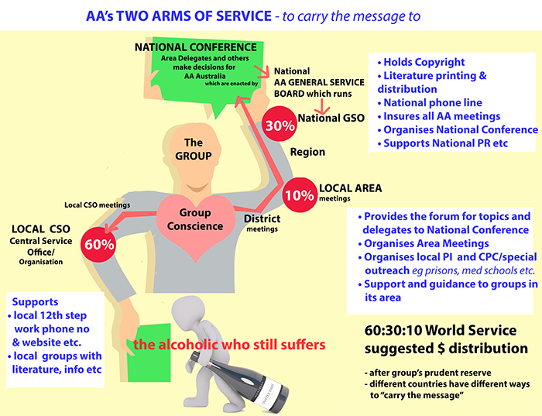

Proposed Changes to the Service Structure – in red:
