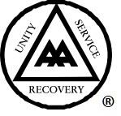

General Service Conference 2024

TOPIC SUBMISSION FORM

CLOSING DATE: 4PM AEST SUNDAY 9 JUNE 2024

About Topics

A Topic is an idea that is sent to the Conference that is intended, directly or indirectly, to help the Fellowship advance its Primary Purpose (helping alcoholics to achieve and maintain sobriety) from Alcoholics Anonymous Guidelines (GL-28).
Topics are the way in which members can get something discussed at the annual Australian General Service Conference. The annual General Service Conference (GSC) serves the members, and topics allow the AA movement to express its views upon all matters of vital AA policy and all hazardous deviations from AA Tradition.

The diagram below illustrates how topics progress through the General Service Structure to the annual General Service Conference.
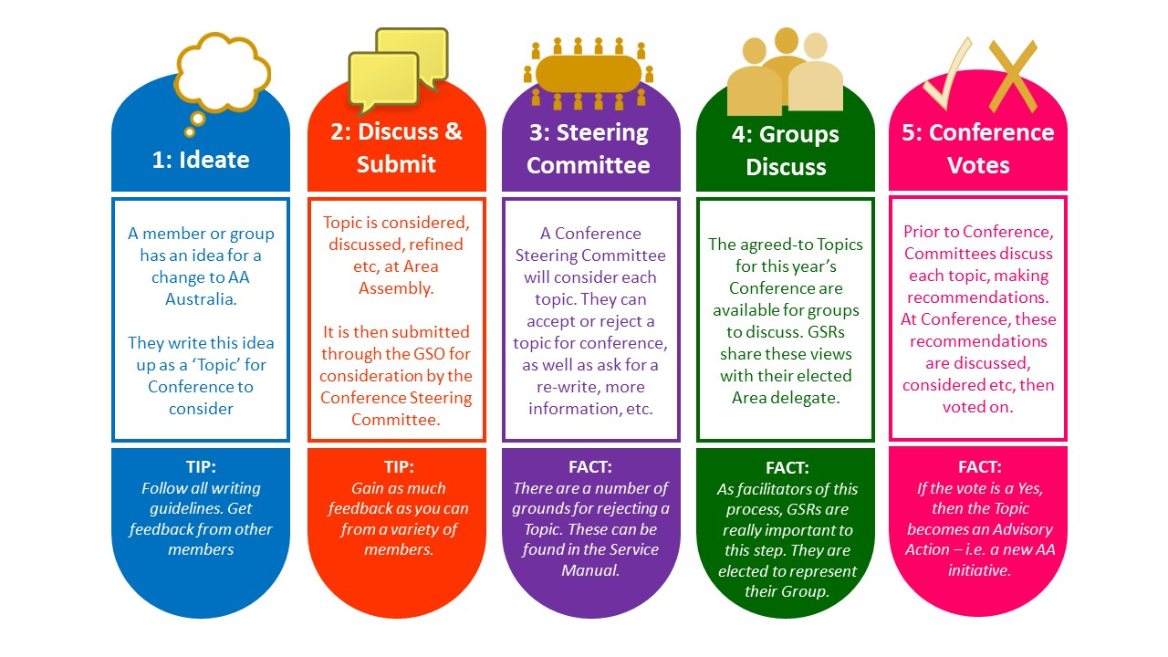
Who can submit a topic?

Topics can be submitted by anyone in AA.

- Individual members or a pair of members or a small group of members
- A Home Group
- A District
- An Area
- The General Service Board or other General Service Committee

Topics can be submitted under a contact name and details, or completely anonymously, that is the choice of the author(s). Conference, however, suggests that, if possible, topics are submitted through the Area.
Writing a topic

This section provides some suggestions for writing a clear topic. There is also a checklist at the end of the form (see also Guideline GL-28).

- Make sure your topic for the General Service Conference contains a single issue, opportunity or idea

- Try to make sure your submission states the issue for consideration. State what the topic is seeking in the title if possible. Experience has shown that confusion around what a topic is actually seeking can be avoided if it stated very clearly from the outset.
- Be aware that the first section introducing the topic is what is published as a ‘top line’ in AA Around Australia and other places
- Indicates a recommendation for action
- Provides only supporting information relevant to the issue and recommendation
- Make sure it is a clear description of what needs to be done? (ie not a general statement of dissatisfaction)

- If you are unhappy with something, state what that is, and why, and a clear suggestion on what action you think would change it for the good of AA as a whole
- Is all content trustworthy and accurate?

- Does it leave out any names of members?

- Is it within the word limits noted on the topic form?

- Does it avoid the General Service Conference assuming responsibilities that belong to Groups, Districts or Areas?

- Does it avoid any endorsement of personal opinions? Is it just a local issue?

- Please make sure that your topic addresses an issue that will be for the benefit of AA as a whole, rather than something that only you may be interested in.
- Consider discussing the topic with your Group, District (if your group is part of a District) and Area Assembly?

- Discussing at Area may provide useful input and more experience to develop and strengthen the ideas covered by the topic. This process can make what is being asked for easier for Conference members to consider. Please note though that there is no extra weight given to a topic simply because it came through an Area. Topics are all reviewed on the merits of their content.

- Have you added extra information as attachments? One attachment per topic is permitted. Attachments must be examples or evidence that support the topic, not just an extension of the topic. For example:
  - Images
  - Diagrams
  - Examples of posters or leaflets
  - Historical Data
  - Maps

- Submit your Topic.

How to submit a topic

- Email: gso@aa.org.au
- Post:1/1 Garnet St Rockdale, NSW 2216
- Online Form: Link (Coming at a later date in 2024)

Conference prefers that you provide at least one way to contact you in case the Conference Steering Committee (CSC) needs to clarify anything. (N.B. The General Service Office keeps your contact details confidential and does not forward them to anyone).

Topics need to be submitted by the closing date each year to be considered at that year’s General Service Conference.

Closing Date for topics for 2024 is 4pm Sunday 9 June, 2024.

Topics received after the closing date will be held over for consideration by the 2025 General Service Conference.

What happens after submission?

After the closing date the GSO will remove the contact details. Contact details are kept securely in case further information is needed and then the list of submitted topics is sent to the Conference Steering Committee who review each topic against criteria including the following:

1. Is the topic relevant to the entire Australian fellowship? Or is it a localised issue that is perhaps better suited to a discussion with your Group, District or Area?
2. Is the wording respectful and not derogatory towards any individual or section of the fellowship?
3. Is the topic addressing an administrative matter that may not need the entire fellowship to consider? If so, the Conference Steering Committee may send it to the General Service Board for direct action.

Topics which are rejected are returned to the author (if not anonymous) with a brief reason for rejection. The remaining topics are then numbered, allocated to the General Service Conference topic Committees and formatted for review, discussion and circulation to the fellowship.

AA groups throughout Australia are then invited by their GSR to discuss and form a group conscience on each topic. The GSR then takes part in an Area Assembly where the Area Delegate listens to the group conscience of the Area. This provides the Area Delegate with an understanding of the views of the groups in their Area, to inform their thinking and discussion when they discuss the topics at Conference (The group conscience of Australia).

Topics accepted by vote at Conference then become Advisory Actions and are allocated to the relevant AA service entity for action. These are:

- The General Service Board
- The General Service Office staff
- An existing committee or working group
- A new working group

Working groups are small groups of interested and appropriately skilled members coming together after the annual General Service Conference to carry out an Advisory Action (like a project team). Working groups consist of:

- One Trustee – General Service Board member
- Area Delegates
- Members of AA who have interest and skills in the Advisory Action/project. Any member can register their interest in being involved by completing the skills register form on the member website.

Working groups decide how often to meet, and how to carry out the work depending on the project they are working on. They provide regular updates on progress to the Board via the Trustee member(s) of the working group and/or the project management committee. Working groups can request support from the Board and any necessary budget.

Working groups provide either a progress report or their final report to the Conference. Once the project has been completed and Conference accepts the completed piece of work, the working group disbands.

General Service Conference Topic Submission Form

Name:

Email:

Or provide another way to contact you if you prefer:

- Tick if you would like to be part of the working group if the topic is accepted by Conference

TITLE:
Please give your Topic a short title that will make it easy to recognise what it covers?
e.g. Adding a section on safety guidelines to Group Handbook

WHAT YOU WANT TO HAPPEN:
Examples
- You are asking Conference to consider something
- You are asking the Board to do something
- You are asking for a change to a piece of literature
Maximum 150 words, please.

YOUR IDEA
This should be a short and clear statement of the issue, opportunity or your idea. Clearly state your desired outcome.
Start writing your text in the space below. Maximum 150 words, please.

WHAT IS THE BACKGROUND OR REASON FOR THE TOPIC?
Please indicate any reference material used.
Start writing your text in the space below. Maximum 150 words, please.

DO YOU HAVE A SUGGESTED SOLUTION?
Start writing your text in the space below. Maximum 150 words, please.

HOW WILL THE ALCOHOLIC WHO STILL SUFFERS OR THE FELLOWSHIP OF ALCOHOLICS ANONYMOUS BENEFIT FROM THIS SUGGESTION?

Start writing your text in the space below. Maximum 150 words, please.

WHAT ARE THE ESTIMATED COSTS OF IMPLEMENTING THIS SUGGESTION?
Do you think there would be costs involved? Please estimate what you think they might be?
Start writing your text in the space below. Maximum 50 words, please.

IF YOU HAVE ASKED YOUR GROUP, DISTRICT OR AREA TO DISCUSS THIS TOPIC WHAT WAS THE OUTCOME OR FEELING OF THE DISCUSSION?

Start writing your text in the space below. Maximum 50 words, please.

TOPIC CHECKLIST

☐ Does the topic contain one single issue?
☐ Is all content trustworthy and accurate?
☐ Does it leave out any names of members?
☐ Is its within the word limits noted on the topic form?
☐ Is it a clear description of what you would like considered?
☐ Does it avoid Conference assuming responsibilities that belong to Groups, Districts or Areas?
☐ Does it avoid endorsement of personal opinions?
☐ Have you added extra information as an attachment?
☐ Have you checked with your Area Delegate or checked the Key Conference Resolutions document on the Members’ Website to see if similar topics have been discussed recently?

Reminder of how to submit a topic

- Email: gso@aa.org.au
- Post:1/1 Garnet St Rockdale, NSW 2216
- Online Form: Link (Coming in 2024)

Conference prefers that you provide at least one way to contact you in case the Conference Steering Committee (CSC) needs to clarify anything. (N.B. The General Service Office keeps your contact details confidential and does not forward them to anyone.)

